**SCHEDULE**

**TO**

**SCHOOL SUBMISSION**

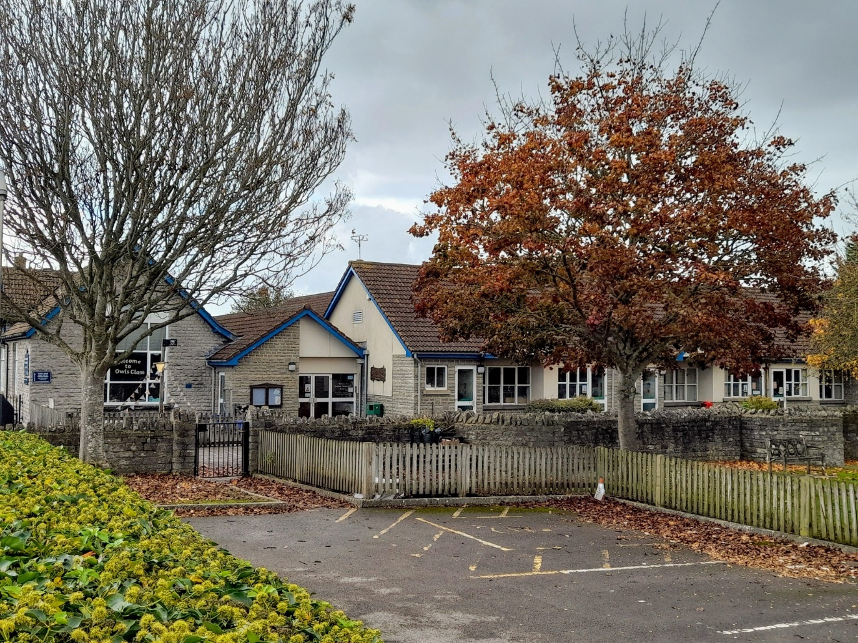

**Protecting Keinton Mandeville Primary School**

**What are the effects of overcrowding in schools?**

Researchers find that overcrowding can reduce students' ability to pay attention to teachers' instruction and even increase students' behaviour issues. The rates of teacher and student absenteeism are more likely to be higher than at schools without overcrowding.

**What are problems with overcrowded classrooms?**

In overcrowded classroom always there is poor interaction, poor class control, poor participation, difficulties in class assessment and a lack of resource.

The researcher used questionnaires to collect data where the findings came up with the facts that noise making, failure to attend each student’s need, restriction of teacher’s movement in the class, cheating in exams, wastage of time setting orders in class, difficulty in marking, and both teachers and students being stressed are the impacts resulting from over crowdedness in classrooms.

Overcrowding leads to heavy teacher workloads creating stressful working conditions for teachers and leads to higher teacher absenteeism.

Over crowdedness diminishes the quality and quantity of teaching and learning with serious implication for attainment of education goals.

* There is not enough of the teacher to go around. ...
* Overcrowding increases classroom discipline issues. ...
* Struggling students fall further behind. ...
* Standardised test scores suffer. ...
* The overall noise level is increased. ...
* Teacher stress is increased often leading to teacher burnout.

Overcrowding creates unsafe environments and makes teaching and learning more difficult. Schools may need to teach students in corridors, storage rooms, offices and other areas never intended to be used for instructional purposes.

See link to article abstract:

[**Examining the effect of class size on classroom engagement and teacher–pupil interaction: Differences in relation to pupil prior attainment and primary vs. secondary schools - ScienceDirect**](https://www.sciencedirect.com/science/article/abs/pii/S0959475211000260?via%3Dihub)

**Greater Noise and Distractions**

Having more of anything can lead to chaos. An ideal classroom would be limited to 15 to 20 students, but many classrooms today have over 30 or even 40 students. Naturally, the more students there are, the noisier it gets—even in classrooms that are effectively managed. The increased noise level can make it harder for pupils to concentrate, affecting learning outcomes, and more difficult for teachers to focus, leading to more stress and possible burnout.

**Less Personalised Instruction**

The greater the number of students in a classroom, the less attention each student can receive from the teacher. This particularly affects students who are struggling and need the extra attention. This impacts on learning outcomes, as these students are more likely to have lower test scores and grades as a result.

**Increase in Disciplinary Problems**

Overcrowding can lead to a chaotic classroom environment that is more difficult for the teacher to manage. The increased number of students leads to a greater likelihood of disruptive behaviour and conflicts among pupils, especially with fewer resources to accommodate the extra students. Teachers in overcrowded classrooms often devote more time to dealing with behavioural issues and less time to teaching—something no teacher desires.

**Poor Building or Environmental Conditions**

Schools with overcrowded classrooms are also more likely to have poor building or environmental conditions. Overcrowded schools “were more likely than schools that were either under enrolled or within 5% of their capacity to have at least one building feature in less than adequate condition.” This could include poor air conditioning and heating systems, lighting, ventilation, indoor air quality, acoustics or noise control, and physical security.

**Increase in Illness Risk**

The poor building conditions found in overcrowded schools also pose health risks for students and teachers. Poor ventilation, lighting, acoustics, and classroom temperatures can expose students to allergens, pollutants, and even chemicals that affect health, attendance, and performance. Of course, in terms of the ongoing fight against COVID-19, overcrowded classrooms don’t lend themselves to social distancing and therefore make it easier for germs to spread. This has become a major concern for parents, teachers, and students.

To ease overcrowding, many schools implement strategies such as staggered lunchtimes.

Some of the difficulties include discipline, lack of space in the classroom, inability of the teacher to assist weak learners, increased workload in terms of marking and instructional problems.

The research summarized below indicates that when enrolment greatly exceeds the design capacity of a school that student academic performance declines along with the “enjoyability” of school for students, faculty and parents.

A portion of the students may be forced to eat lunch early or late in the day.

Traffic congestion and pedestrian safety becomes more of a problem at pick-up and drop-off times.

Only a portion of parents can fit into the ‘hall’ to see their child perform.

Overcrowding reduces students’ ability to pay attention and increases school violence. In such schools, students achieve less; rates of teacher and student absenteeism are higher than at schools that do not have these problems.

**Research has also linked overcrowded schools to**[**increased bullying**](http://www.ncbi.nlm.nih.gov/pmc/articles/PMC4231780/)**.**

Overcrowding of classrooms leads to the over usage of facilities, equipment and materials and the over use of the school environment. The schools that are overcrowded exist with environmental and classroom problems like truancy, noise making, medical/health problems, fighting among others.

The need to add aesthetic value to educational facilities not only to enhance their utilization value but also to make them more healthy, safe and convenient to use and maintain is hampered by overcrowding.

SHOCK

September 2022